TABLE CREATED AND INSERTED

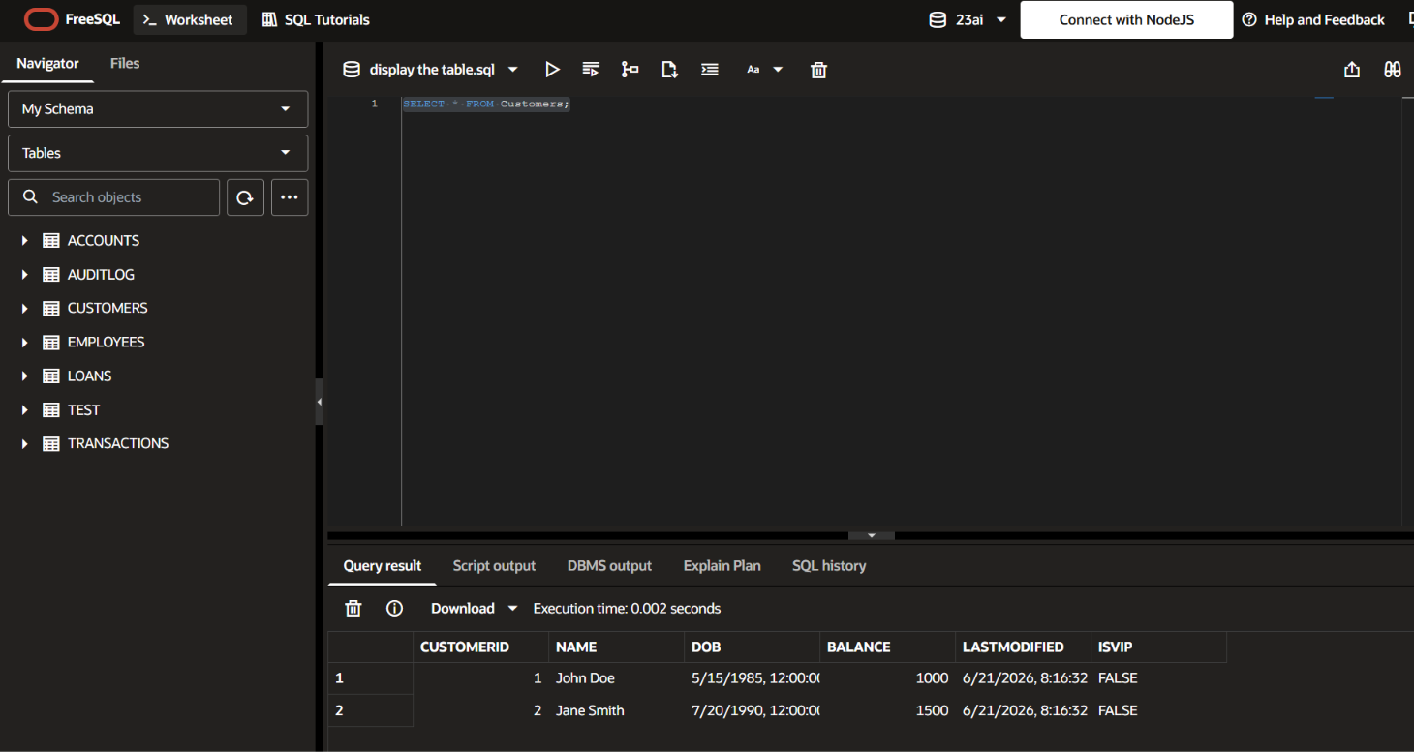

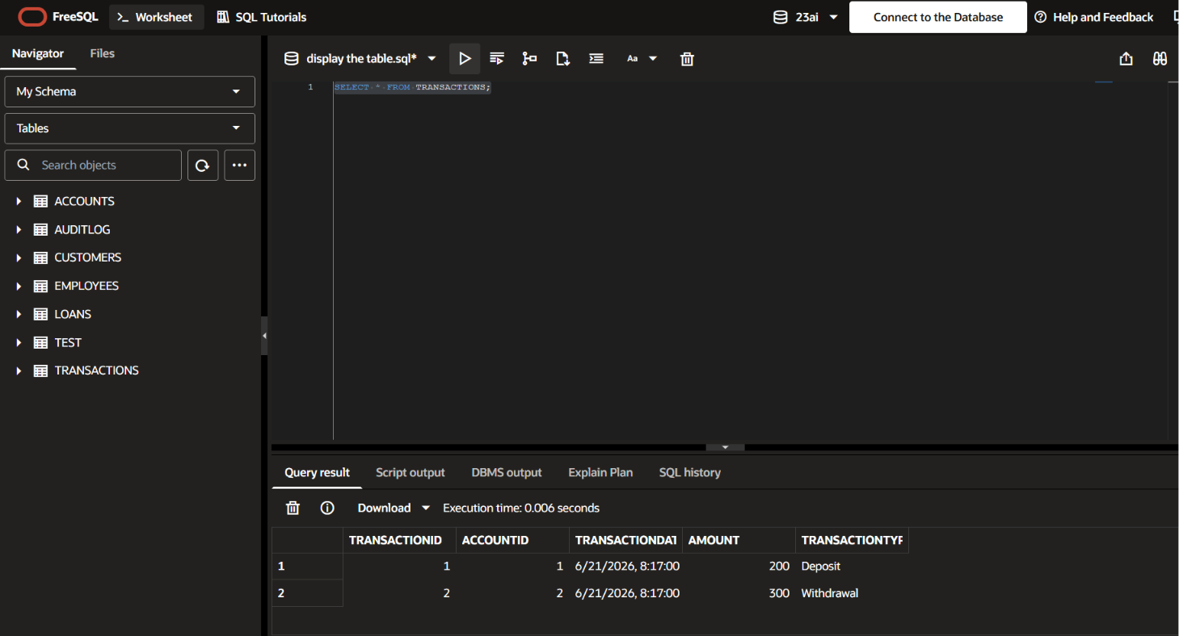
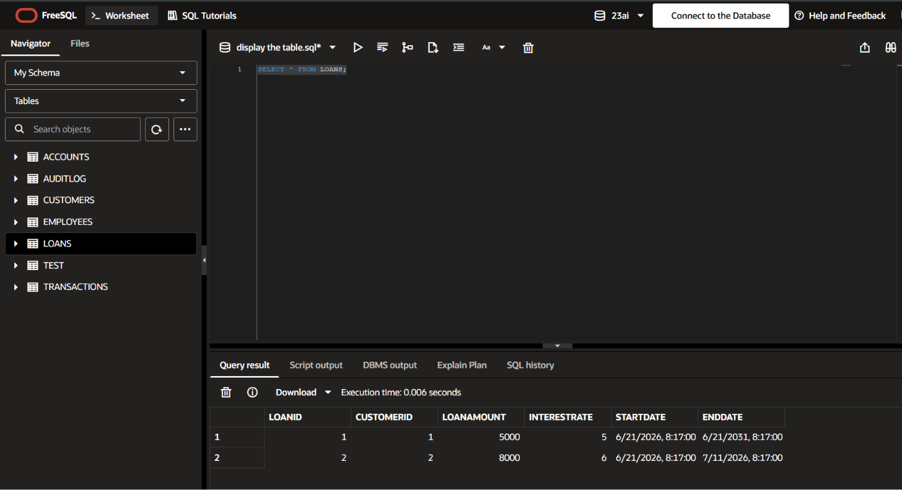

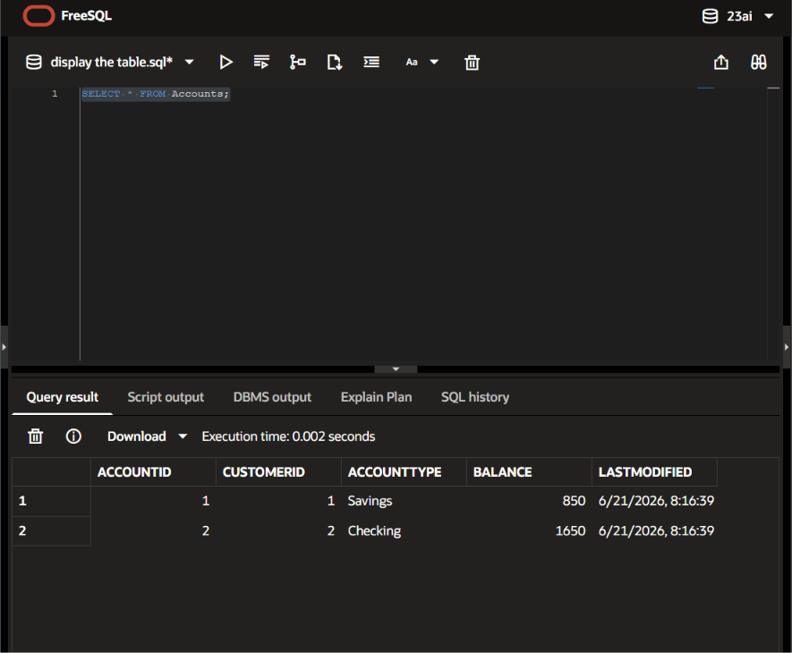
Exercise 1: Control Structures

Scenario 1:

SET SERVEROUTPUT ON;

DECLARE
v_age NUMBER;
BEGIN
FOR c IN (
SELECT CustomerID, DOB
FROM Customers
)
LOOP
v_age := FLOOR(MONTHS_BETWEEN(SYSDATE, c.DOB) / 12);

IF v_age > 60 THEN
UPDATE Loans
SET InterestRate = InterestRate - 1
WHERE CustomerID = c.CustomerID;

DBMS_OUTPUT.PUT_LINE(
'1% discount applied to Customer ID: '
|| c.CustomerID
);
END IF;
END LOOP;

COMMIT;
END;
/

SELECT LoanID,
CustomerID,
InterestRate
FROM Loans;

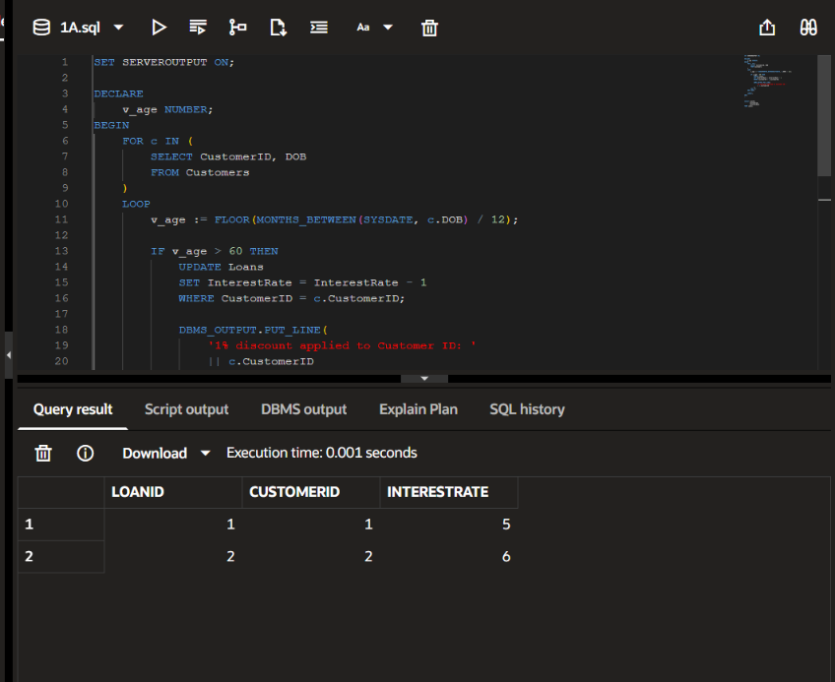

Scenario 2:

SET SERVEROUTPUT ON;

BEGIN
FOR c IN (
SELECT CustomerID,
Balance
FROM Customers
)
LOOP
IF c.Balance > 10000 THEN

UPDATE Customers
SET IsVIP = 'TRUE'
WHERE CustomerID = c.CustomerID;

DBMS_OUTPUT.PUT_LINE(
'VIP Status Assigned : '
|| c.CustomerID
);

END IF;
END LOOP;

COMMIT;
END;
/

-- Verify
SELECT CustomerID,
Name,
Balance,
IsVIP
FROM Customers;

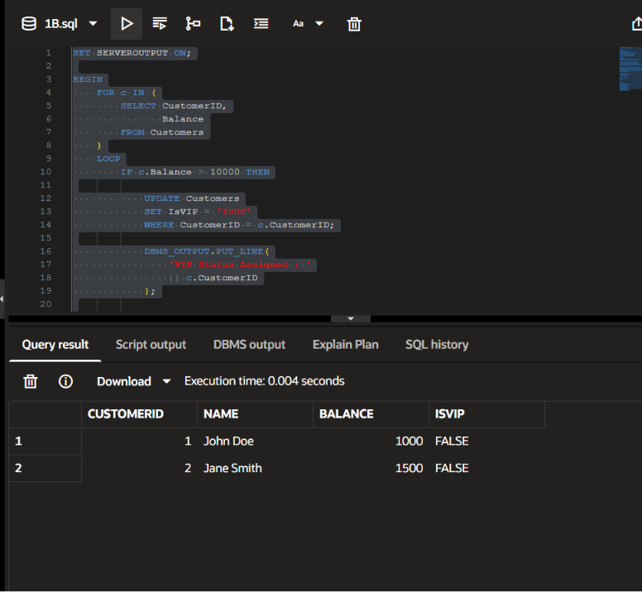

Scenario 3

SET SERVEROUTPUT ON;

BEGIN

FOR l IN (
SELECT LoanID,
CustomerID,
EndDate
FROM Loans
WHERE EndDate BETWEEN SYSDATE
AND SYSDATE + 30
)
LOOP

DBMS_OUTPUT.PUT_LINE(
'Reminder: Loan '
|| l.LoanID
|| ' for Customer '
|| l.CustomerID
|| ' is due on '
|| TO_CHAR(l.EndDate,'DD-MON-YYYY')
);

END LOOP;

END;
/
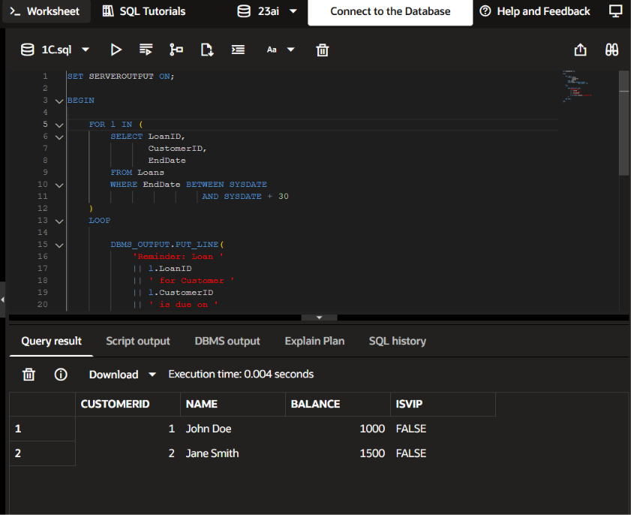

Exercise 2: Error Handling
Scenario 1:

SET SERVEROUTPUT ON;

CREATE OR REPLACE PROCEDURE SafeTransferFunds(
p_from_account NUMBER,
p_to_account NUMBER,
p_amount NUMBER
)
IS
v_balance NUMBER;
BEGIN

SELECT Balance
INTO v_balance
FROM Accounts
WHERE AccountID = p_from_account;

IF v_balance < p_amount THEN
RAISE_APPLICATION_ERROR(
-20001,
'Insufficient Funds'
);
END IF;

UPDATE Accounts
SET Balance = Balance - p_amount
WHERE AccountID = p_from_account;

UPDATE Accounts
SET Balance = Balance + p_amount
WHERE AccountID = p_to_account;

COMMIT;

DBMS_OUTPUT.PUT_LINE('Transfer Successful');

EXCEPTION
WHEN OTHERS THEN
ROLLBACK;
DBMS_OUTPUT.PUT_LINE(SQLERRM);
END;
/

-- Test

BEGIN
SafeTransferFunds(1,2,200);
END;
/

-- Verify

SELECT AccountID,
Balance
FROM Accounts
ORDER BY AccountID;

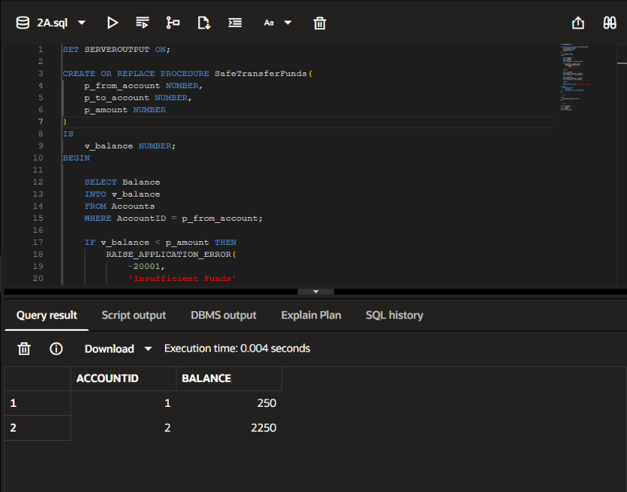

Scenario 2:

SET SERVEROUTPUT ON;

CREATE OR REPLACE PROCEDURE UpdateSalary(
p_empid NUMBER,
p_percent NUMBER
)
IS
BEGIN

UPDATE Employees
SET Salary = Salary + (Salary * p_percent / 100)
WHERE EmployeeID = p_empid;

IF SQL%ROWCOUNT = 0 THEN
RAISE NO_DATA_FOUND;
END IF;

COMMIT;

DBMS_OUTPUT.PUT_LINE('Salary Updated');

EXCEPTION

WHEN NO_DATA_FOUND THEN
DBMS_OUTPUT.PUT_LINE(
'Employee ID Not Found'
);

WHEN OTHERS THEN
DBMS_OUTPUT.PUT_LINE(SQLERRM);

END;
/

-- Test

BEGIN
UpdateSalary(1,10);
END;
/

-- Verify

SELECT EmployeeID,
Name,
Salary
FROM Employees;

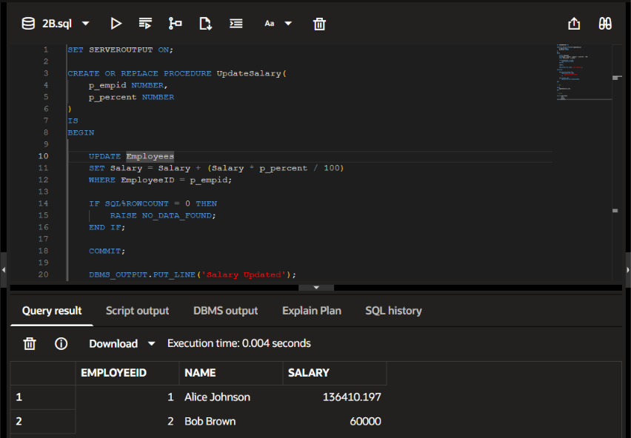

Scenario 3

CREATE OR REPLACE PROCEDURE TransferFunds(
p_from_account NUMBER,
p_to_account NUMBER,
p_amount NUMBER
)
IS
v_balance NUMBER;
BEGIN
SELECT Balance
INTO v_balance
FROM Accounts
WHERE AccountID = p_from_account
FOR UPDATE;

IF v_balance < p_amount THEN
RAISE_APPLICATION_ERROR(-20001, 'Insufficient balance');
END IF;

UPDATE Accounts
SET Balance = Balance - p_amount,
LastModified = SYSDATE
WHERE AccountID = p_from_account;

UPDATE Accounts
SET Balance = Balance + p_amount,
LastModified = SYSDATE
WHERE AccountID = p_to_account;

COMMIT;

EXCEPTION
WHEN OTHERS THEN
ROLLBACK;
DBMS_OUTPUT.PUT_LINE('Error: ' || SQLERRM);
END;
/

SELECT * FROM Accounts WHERE AccountID IN (1,2);
SELECT * FROM Transactions;

BEGIN
TransferFunds(1, 2, 200);
END;
/

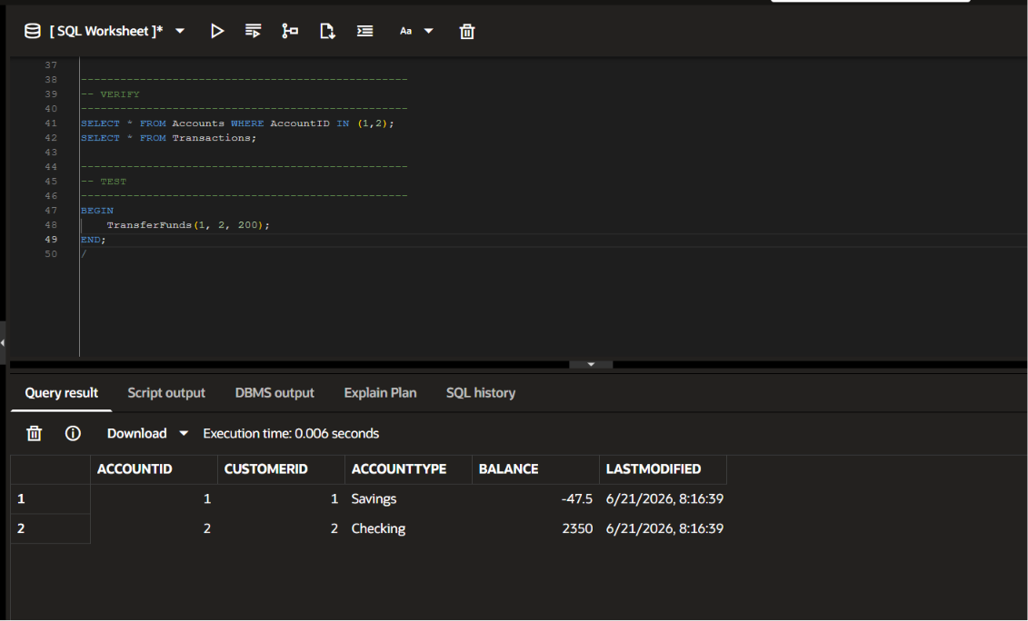

Exercise 3: Stored Procedures

Scenario 1

SET SERVEROUTPUT ON;

CREATE OR REPLACE PROCEDURE ProcessMonthlyInterest
IS
BEGIN

UPDATE Accounts
SET Balance = Balance + (Balance * 0.01)
WHERE AccountType = 'Savings';

COMMIT;

DBMS_OUTPUT.PUT_LINE(
'Monthly Interest Applied'
);

END;
/

-- Test

BEGIN
ProcessMonthlyInterest;
END;
/

-- Verify

SELECT AccountID,
AccountType,
Balance
FROM Accounts;

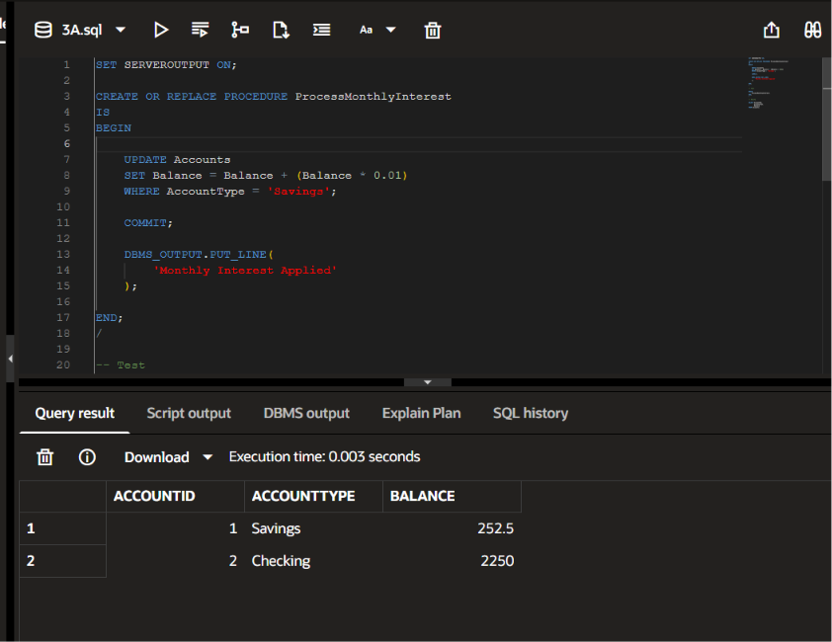

Scenario 2

SET SERVEROUTPUT ON;

CREATE OR REPLACE PROCEDURE UpdateEmployeeBonus(
p_department VARCHAR2,
p_bonus NUMBER
)
IS
BEGIN

UPDATE Employees
SET Salary = Salary + (Salary * p_bonus / 100)
WHERE Department = p_department;

COMMIT;

DBMS_OUTPUT.PUT_LINE(
'Bonus Applied'
);

END;
/

-- Test

BEGIN
UpdateEmployeeBonus(
'IT',
10
);
END;
/

-- Verify

SELECT EmployeeID,
Name,
Department,
Salary
FROM Employees;

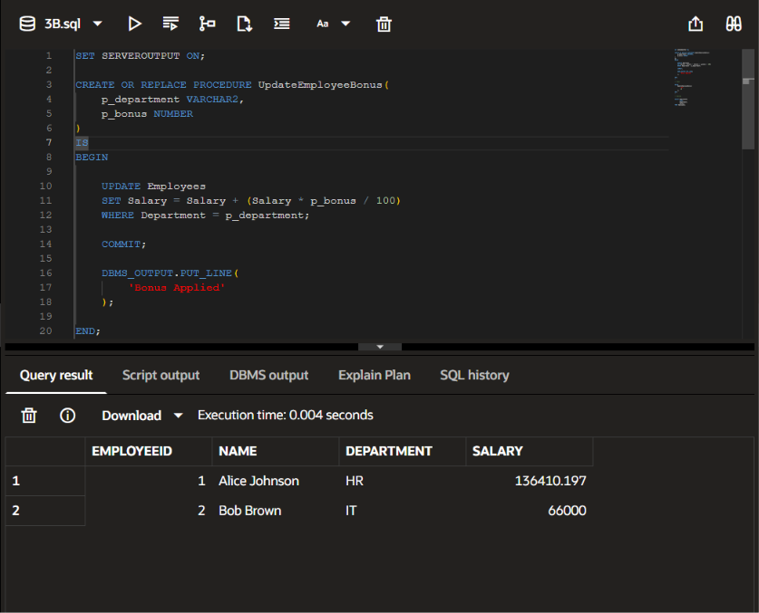

Scenario 3

SET SERVEROUTPUT ON;

CREATE OR REPLACE PROCEDURE TransferFunds(
p_from NUMBER,
p_to NUMBER,
p_amount NUMBER
)
IS
v_balance NUMBER;
BEGIN

SELECT Balance
INTO v_balance
FROM Accounts
WHERE AccountID = p_from;

IF v_balance < p_amount THEN
DBMS_OUTPUT.PUT_LINE(
'Insufficient Funds'
);
RETURN;
END IF;

UPDATE Accounts
SET Balance = Balance - p_amount
WHERE AccountID = p_from;

UPDATE Accounts
SET Balance = Balance + p_amount
WHERE AccountID = p_to;

COMMIT;

DBMS_OUTPUT.PUT_LINE(
'Transfer Successful'
);

END;
/

-- Test

BEGIN
TransferFunds(
1,
2,
100
);
END;
/

-- Verify

SELECT AccountID,
Balance
FROM Accounts
ORDER BY AccountID;

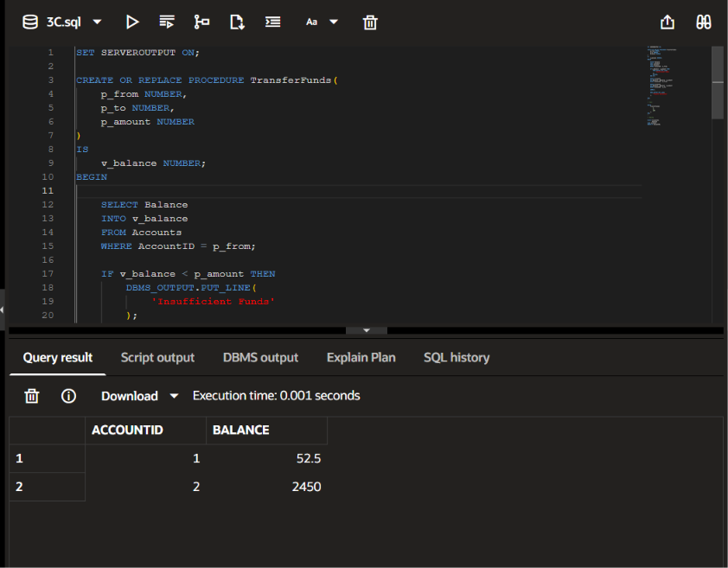

Exercise 4: Functions

Scenario 1

SET SERVEROUTPUT ON;

CREATE OR REPLACE FUNCTION CalculateAge(
p_dob DATE
)
RETURN NUMBER
IS
BEGIN
RETURN FLOOR(
MONTHS_BETWEEN(
SYSDATE,
p_dob
) / 12
);
END;
/

-- Test + Verify

SELECT CustomerID,
Name,
CalculateAge(DOB) AS AGE
FROM Customers;

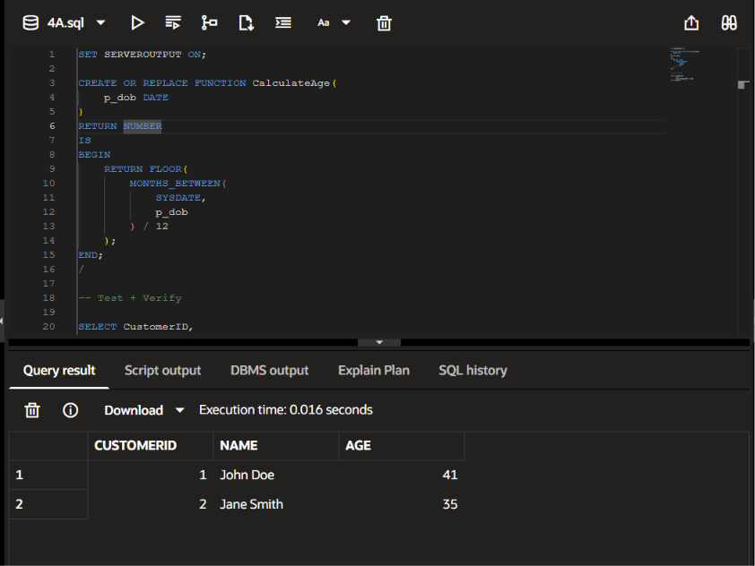

Scenario 2

SET SERVEROUTPUT ON;

CREATE OR REPLACE FUNCTION CalculateMonthlyInstallment(
p_amount NUMBER,
p_rate NUMBER,
p_years NUMBER
)
RETURN NUMBER
IS
v_emi NUMBER;
BEGIN

v_emi :=
(p_amount * (p_rate/1200))
/
(1 - POWER(
1 + (p_rate/1200),
-(p_years*12)
));

RETURN ROUND(v_emi,2);

END;
/

-- Test + Verify

SELECT CalculateMonthlyInstallment(
5000,
5,
5
) AS EMI
FROM dual;

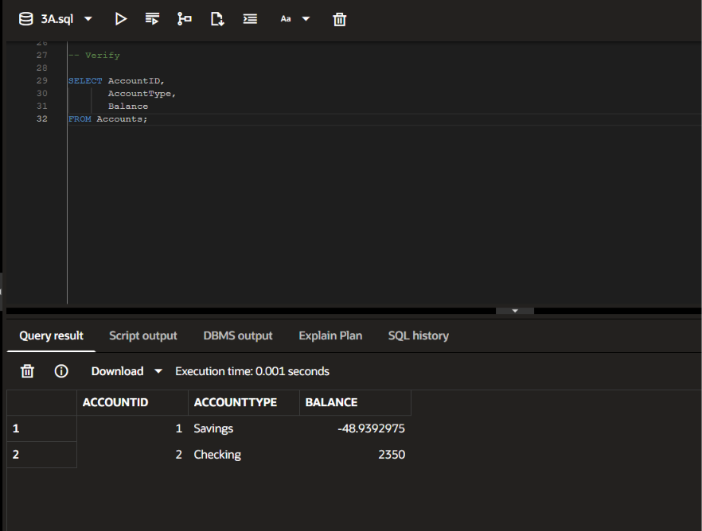

Scenario 3

SET SERVEROUTPUT ON;

CREATE OR REPLACE FUNCTION HasSufficientBalance(
p_account NUMBER,
p_amount NUMBER
)
RETURN VARCHAR2
IS
v_balance NUMBER;
BEGIN

SELECT Balance
INTO v_balance
FROM Accounts
WHERE AccountID = p_account;

IF v_balance >= p_amount THEN
RETURN 'TRUE';
ELSE
RETURN 'FALSE';
END IF;

END;
/

-- Test + Verify

SELECT HasSufficientBalance(
1,
500
) AS RESULT
FROM dual;

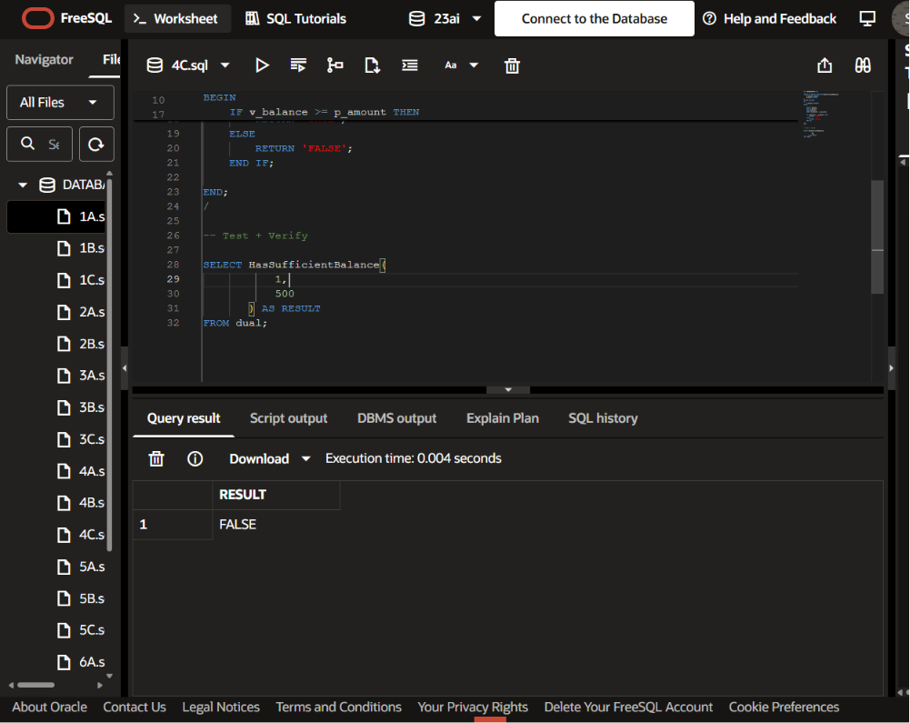

Exercise 5: Triggers

Scenario 1

CREATE OR REPLACE TRIGGER UpdateCustomerLastModified
BEFORE UPDATE ON Customers
FOR EACH ROW
BEGIN
:NEW.LastModified := SYSDATE;
END;
/

UPDATE Customers
SET Balance = Balance + 500
WHERE CustomerID = 1;

SELECT CustomerID,
Name,
Balance,
LastModified
FROM Customers
WHERE CustomerID = 1;

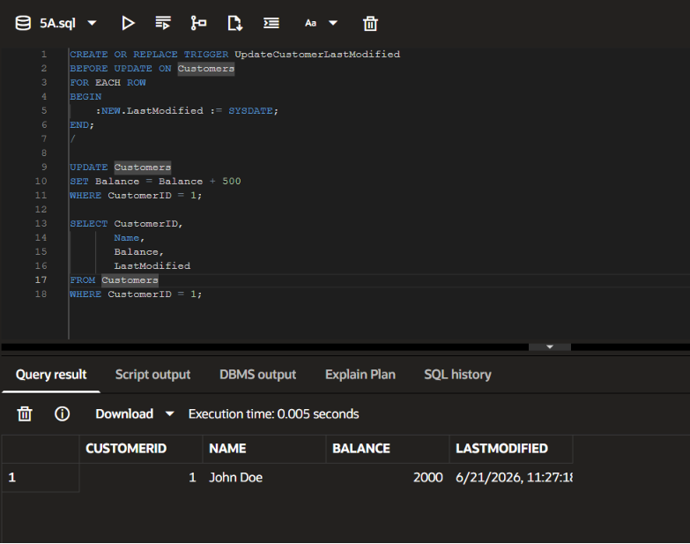

Scenario 2

CREATE TABLE AuditLog (
LogID NUMBER GENERATED ALWAYS AS IDENTITY,
TransactionID NUMBER,
LogDate DATE
);

CREATE OR REPLACE TRIGGER LogTransaction
AFTER INSERT ON Transactions
FOR EACH ROW
BEGIN
INSERT INTO AuditLog (
TransactionID,
LogDate
)
VALUES (
:NEW.TransactionID,
SYSDATE
);
END;
/

INSERT INTO Transactions (
TransactionID,
AccountID,
TransactionDate,
Amount,
TransactionType
)
VALUES (
100,
1,
SYSDATE,
500,
'Deposit'
);

SELECT *
FROM AuditLog;

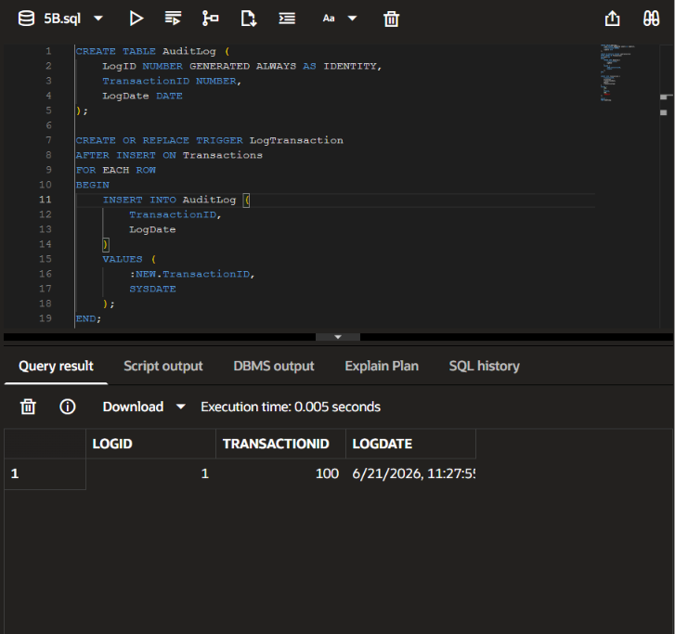

Scenario 3

CREATE TABLE AuditLog (
LogID NUMBER GENERATED ALWAYS AS IDENTITY,
TransactionID NUMBER,
LogDate DATE
);

CREATE OR REPLACE TRIGGER LogTransaction
AFTER INSERT ON Transactions
FOR EACH ROW
BEGIN
INSERT INTO AuditLog (
TransactionID,
LogDate
)
VALUES (
:NEW.TransactionID,
SYSDATE
);
END;
/

INSERT INTO Transactions (
TransactionID,
AccountID,
TransactionDate,
Amount,
TransactionType
)
VALUES (
100,
1,
SYSDATE,
500,
'Deposit'
);

SELECT *
FROM AuditLog;
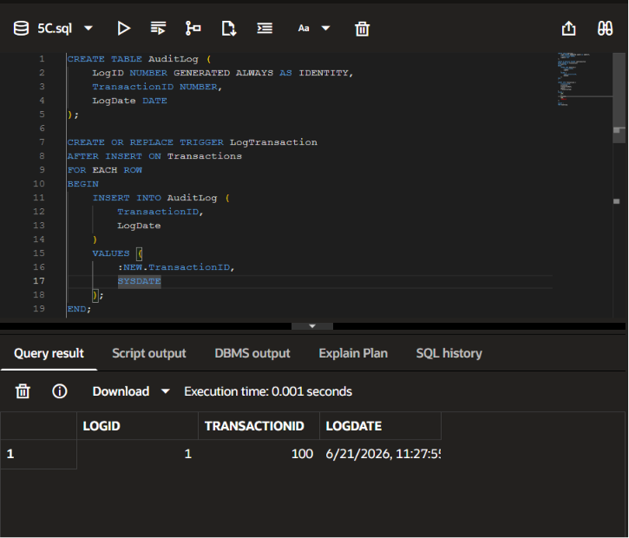

Exercise 6: Cursors

Scenario 1

SET SERVEROUTPUT ON;

DECLARE

CURSOR GenerateMonthlyStatements IS
SELECT TransactionID,
AccountID,
Amount,
TransactionType
FROM Transactions
WHERE TRUNC(TransactionDate,'MM')
=
TRUNC(SYSDATE,'MM');

BEGIN

FOR t IN GenerateMonthlyStatements LOOP

DBMS_OUTPUT.PUT_LINE(
'Transaction ID: ' || t.TransactionID ||
' Account: ' || t.AccountID ||
' Amount: ' || t.Amount ||
' Type: ' || t.TransactionType
);

END LOOP;

END;
/
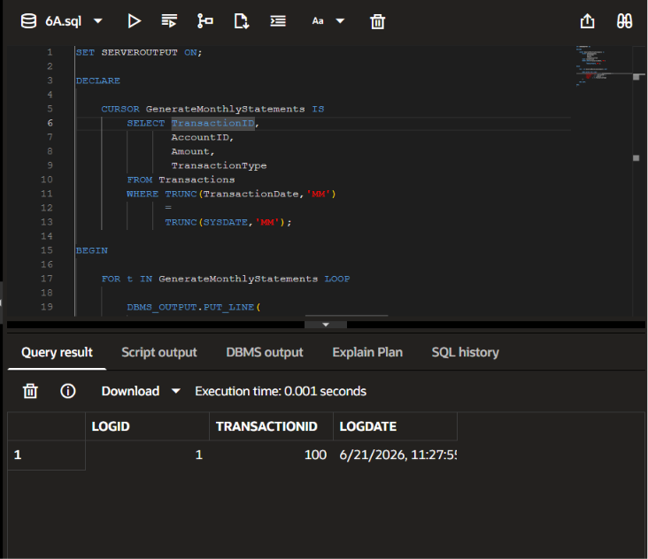

Scenario 2

SET SERVEROUTPUT ON;

DECLARE

CURSOR GenerateMonthlyStatements IS
SELECT TransactionID,
AccountID,
Amount,
TransactionType
FROM Transactions
WHERE TRUNC(TransactionDate,'MM')
=
TRUNC(SYSDATE,'MM');

BEGIN

FOR t IN GenerateMonthlyStatements LOOP

DBMS_OUTPUT.PUT_LINE(
'Transaction ID: ' || t.TransactionID ||
' Account: ' || t.AccountID ||
' Amount: ' || t.Amount ||
' Type: ' || t.TransactionType
);

END LOOP;

END;
/
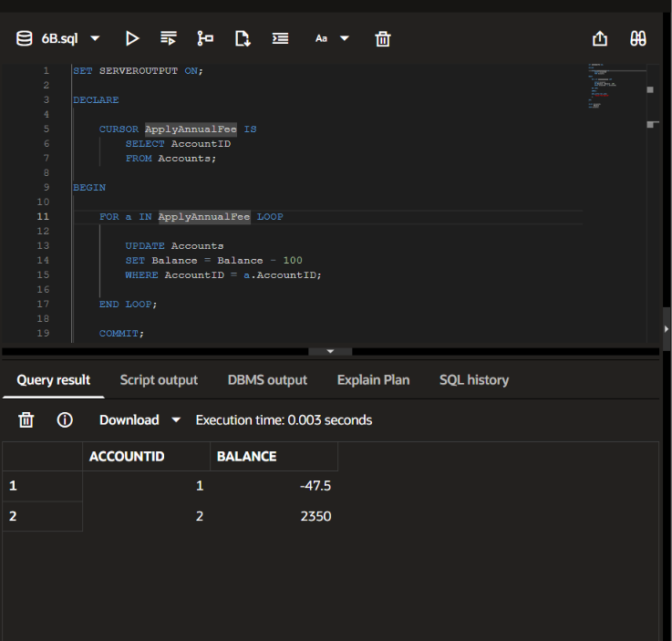

Scenario 3

SET SERVEROUTPUT ON;

DECLARE

CURSOR UpdateLoanInterestRates IS
SELECT LoanID,
InterestRate
FROM Loans;

BEGIN

FOR l IN UpdateLoanInterestRates LOOP

UPDATE Loans
SET InterestRate = l.InterestRate + 0.5
WHERE LoanID = l.LoanID;

END LOOP;

COMMIT;

DBMS_OUTPUT.PUT_LINE(
'Interest Rates Updated'
);

END;
/

SELECT LoanID,
InterestRate
FROM Loans;

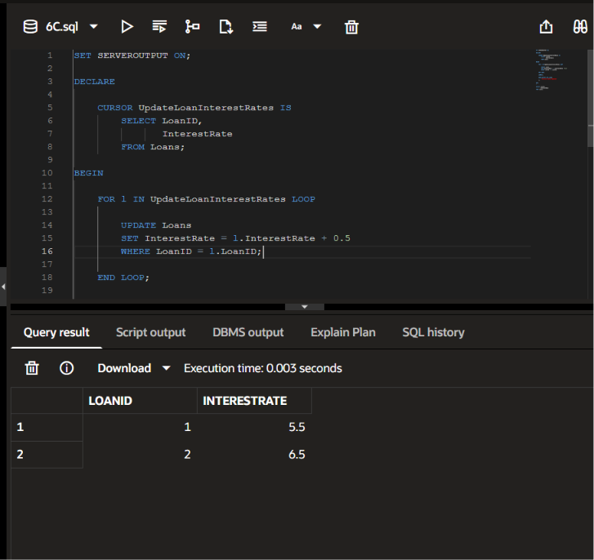

Exercise 7: Packages

Scenario 1

CREATE OR REPLACE PACKAGE CustomerManagement AS

PROCEDURE AddCustomer(
p_id NUMBER,
p_name VARCHAR2,
p_dob DATE,
p_balance NUMBER
);

PROCEDURE UpdateCustomer(
p_id NUMBER,
p_name VARCHAR2
);

FUNCTION GetCustomerBalance(
p_id NUMBER
) RETURN NUMBER;

END CustomerManagement;
/

CREATE OR REPLACE PACKAGE BODY CustomerManagement AS

PROCEDURE AddCustomer(
p_id NUMBER,
p_name VARCHAR2,
p_dob DATE,
p_balance NUMBER
)
IS
BEGIN
INSERT INTO Customers
VALUES (
p_id,
p_name,
p_dob,
p_balance,
SYSDATE,
NULL
);
END;

PROCEDURE UpdateCustomer(
p_id NUMBER,
p_name VARCHAR2
)
IS
BEGIN
UPDATE Customers
SET Name = p_name
WHERE CustomerID = p_id;
END;

FUNCTION GetCustomerBalance(
p_id NUMBER
)
RETURN NUMBER
IS
v_balance NUMBER;
BEGIN
SELECT Balance
INTO v_balance
FROM Customers
WHERE CustomerID = p_id;

RETURN v_balance;
END;

END CustomerManagement;
/

BEGIN
CustomerManagement.AddCustomer(
20,
'Sam Wilson',
DATE '1995-04-10',
8000
);
END;
/

SELECT CustomerManagement.GetCustomerBalance(20)
FROM dual;

SELECT *
FROM Customers
WHERE CustomerID = 20;

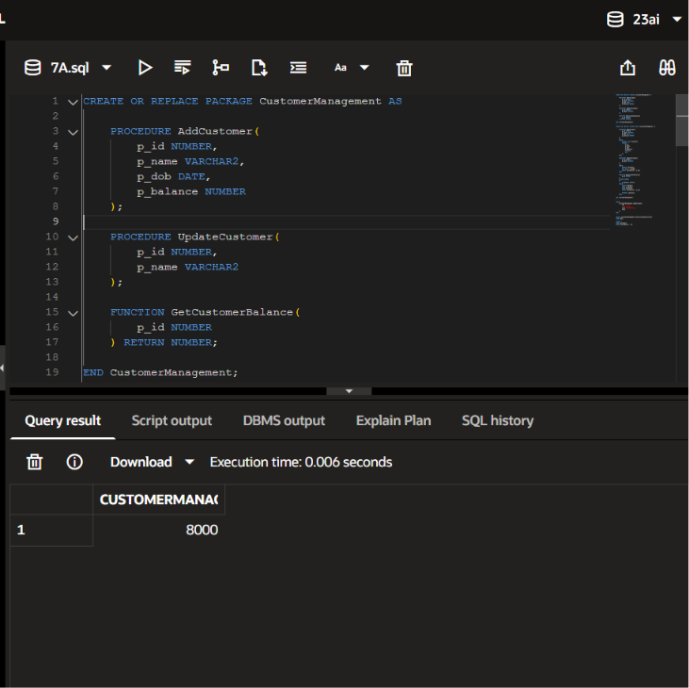
Scenario 2
CREATE OR REPLACE PACKAGE EmployeeManagement AS

PROCEDURE HireEmployee(
p_id NUMBER,
p_name VARCHAR2,
p_position VARCHAR2,
p_salary NUMBER,
p_department VARCHAR2
);

PROCEDURE UpdateEmployee(
p_id NUMBER,
p_salary NUMBER
);

FUNCTION CalculateAnnualSalary(
p_id NUMBER
) RETURN NUMBER;

END EmployeeManagement;
/

CREATE OR REPLACE PACKAGE BODY EmployeeManagement AS

PROCEDURE HireEmployee(
p_id NUMBER,
p_name VARCHAR2,
p_position VARCHAR2,
p_salary NUMBER,
p_department VARCHAR2
)
IS
BEGIN
INSERT INTO Employees
VALUES (
p_id,
p_name,
p_position,
p_salary,
p_department,
SYSDATE
);
END;

PROCEDURE UpdateEmployee(
p_id NUMBER,
p_salary NUMBER
)
IS
BEGIN
UPDATE Employees
SET Salary = p_salary
WHERE EmployeeID = p_id;
END;

FUNCTION CalculateAnnualSalary(
p_id NUMBER
)
RETURN NUMBER
IS
v_salary NUMBER;
BEGIN
SELECT Salary
INTO v_salary
FROM Employees
WHERE EmployeeID = p_id;

RETURN v_salary * 12;
END;

END EmployeeManagement;
/

BEGIN
EmployeeManagement.HireEmployee(
10,
'Chris Evans',
'Analyst',
50000,
'Finance'
);
END;
/

SELECT EmployeeManagement.CalculateAnnualSalary(10)
FROM dual;

SELECT *
FROM Employees
WHERE EmployeeID = 10;

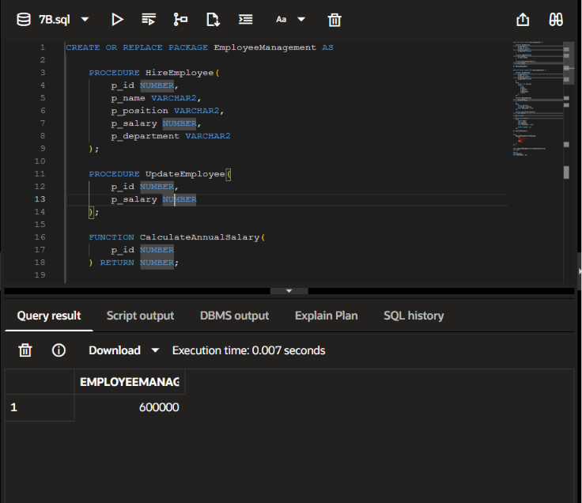

Scenario 3

CREATE OR REPLACE PACKAGE AccountOperations AS

PROCEDURE OpenAccount(
p_account_id NUMBER,
p_customer_id NUMBER,
p_type VARCHAR2,
p_balance NUMBER
);

PROCEDURE CloseAccount(
p_account_id NUMBER
);

FUNCTION GetTotalBalance(
p_customer_id NUMBER
) RETURN NUMBER;

END AccountOperations;
/

CREATE OR REPLACE PACKAGE BODY AccountOperations AS

PROCEDURE OpenAccount(
p_account_id NUMBER,
p_customer_id NUMBER,
p_type VARCHAR2,
p_balance NUMBER
)
IS
BEGIN
INSERT INTO Accounts VALUES (
p_account_id,
p_customer_id,
p_type,
p_balance,
SYSDATE
);
END;

PROCEDURE CloseAccount(
p_account_id NUMBER
)
IS
BEGIN
DELETE FROM Accounts
WHERE AccountID = p_account_id;
END;

FUNCTION GetTotalBalance(
p_customer_id NUMBER
)
RETURN NUMBER
IS
v_total NUMBER;
BEGIN
SELECT NVL(SUM(Balance),0)
INTO v_total
FROM Accounts
WHERE CustomerID = p_customer_id;

RETURN v_total;
END;

END AccountOperations;
/

SELECT * FROM Accounts;
SELECT AccountOperations.GetTotalBalance(1) FROM dual;

BEGIN
AccountOperations.OpenAccount(10, 1, 'Savings', 5000);
AccountOperations.CloseAccount(10);
END;
/

SELECT AccountOperations.GetTotalBalance(1) FROM dual;

